Fixed Assets Handling
The Fixed assets are acquired for use by the business and are not traded by the organization. Fixed assets are also known as tangible assets as property, plant and equipment. Fixed assets are not stock items. Fixed asset accounting includes purchase, depreciation, maintenance and disposal of these assets. The few examples of Fixed Assets are as follows:
- Office equipment
- Computer equipment
- Buildings
- Furniture
- Manufacturing equipment
- Vehicles
- Machinery
In Tally, the fixed assets are created under the group Fixed Assets from the list of Groups in tally. The fixed asset naming convention should be decided. These should be like Asset Category-Year Of Purchase-Location.
Ledger Creation
For example, you purchased fixed assets called laptop for ₹20,000 + IGST of 18% which will amount to ₹3,600.
So, the total amount will be ₹23,600.
For the above example, we have to create new ledger Computer under the head Fixed Assets with setting suitable GST details.
Note: Nature of Goods => Capital Goods
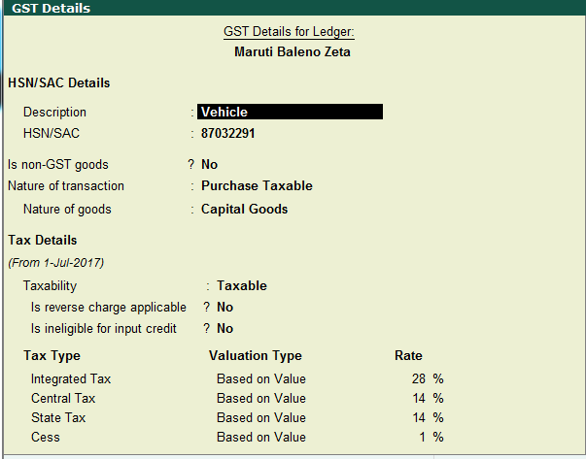

Purchase Entry
Purchase may be entered either in Voucher Mode or Accounting Invoice mode.

Voucher Mode Examples:
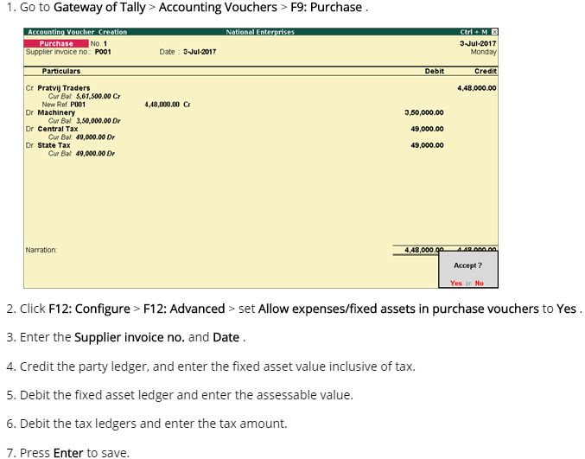

Depreciation :
Is the amount of expense charged against the earning of a company to write off the cost of a product over its useful life, giving consideration to wear and tear, obsolescence and salvage value. If the expense is assumed to have been incurred in equal amounts over the life of the asset, the depreciation method used is the Straight Line (SL) method. If the expense is assumed to have been incurred in decreasing amounts in each business period, the method used is the Written Down Value (WDV) method.

Depreciation Leger will be under Indirect Expense.

All depreciation should be entered in Journal.
- CR Fixed Asset
- DR Depreciation Ledger

Provision :
In accounting terms, a provision account is a current liability and shown on the Liability side of the balance sheet. Similarly, the expense for which provision is created is recognized in the same financial year and recorded on debit side of P&L Account.
We use the depreciation to provision for next fixed asset.

